**Assignment 3**

**Codes:**

**JavaQuiz.java:**

package Assignment3;

/**

* @author Jay Patel

* @version 1.0

*/

import java.util.Scanner;

public class JavaQuiz {

Scanner input = new Scanner(System.in);

private int score = 0 ;

String questions[][]=new String[3][6];

/**

* set values of array

*/

public void setQuestions(){

questions[0][0] = "1. What is Java?";

questions[1][0] = "2. Stack is a ?";

questions[2][0] = "3. Latest version of JavaFX is ?";

questions[0][1] = "A. Java is procedural Lang ";

questions[1][1] = "A. User Defined Class ";

questions[2][1] = "A. 6 ";

questions[0][2] = "B. Java is OOP Language ";

questions[1][2] = "B. Collection Class ";

questions[2][2] = "B. 2 ";

questions[0][3] = "C. java is not a language ";

questions[1][3] = "C. Both A and B ";

questions[2][3] = "C. 11 ";

questions[0][4] = "D. java is not a language ";

questions[1][4] = "D. None of these ";

questions[2][4] = "D. 14 ";

questions[0][5] = "B";

questions[1][5] = "B";

questions[2][5] = "C";

}

/**

* give questions and take answer as a input

*

*/

public void attemptTest(){

int row,col;

for (row = 0; row <questions.length ; row++) {

for (col = 0; col < questions[row].length-1; col++) {

System.out.println(questions[row][col]);

}

System.out.println("Enter your answer: ");

String ans = input.next();

checkResult(ans,row);

}

}

/**

*

* @param ans - store input value

* @param row - store original answer value

*/

public void checkResult(String ans,int row) {

if (ans.equalsIgnoreCase(questions[row][5])) {

System.out.println("Your Answer is Correct.\n");

score++;

} else {

System.out.println("Sorry! Your Answer is Incorrect.\n");

}

}

public String toString(){

if(((score*100)/3)>60){

return "Your Score is: "+ score+ "\nCongratulations! You Have Successfully Passed The Test.";

}else {

return "Your Score is: "+ score+"\nSorry! You Have Failed The Test. So, You Will Need To Do It Again!";

}

}

}

**JavaQuizDemo.java:**

package Assignment3;

public class JavaQuizDemo {

public static void main(String[] args) {

JavaQuiz quiz = new JavaQuiz();

quiz.setQuestions();

quiz.attemptTest();

System.out.println(quiz.toString());

}

}

**Screenshots:**

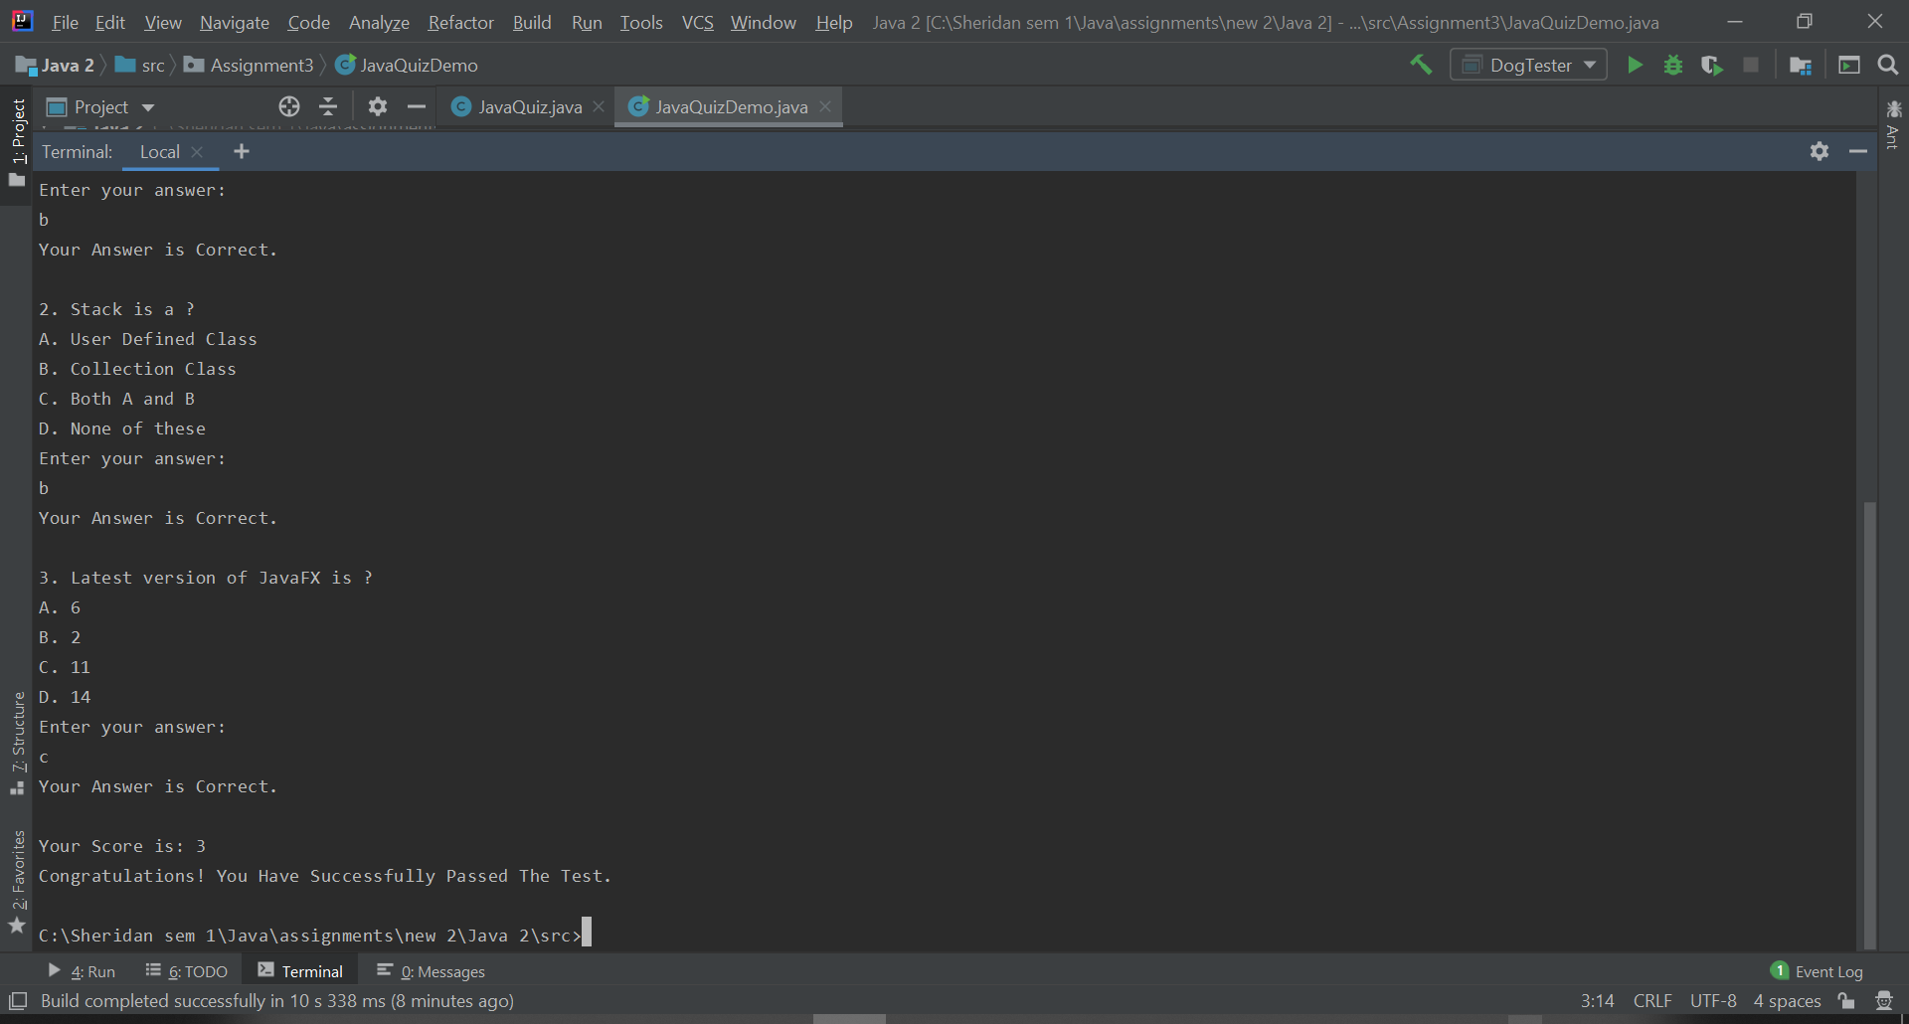

Figure 1 Passed

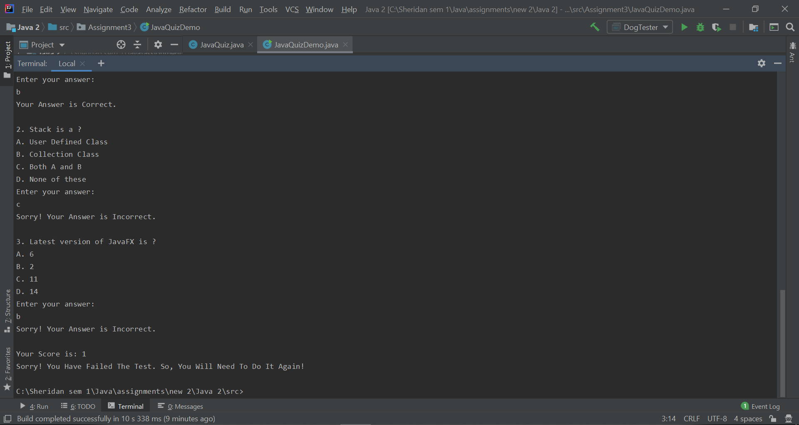

Figure 2 Failed